alpha=0.05

1 run...

Downloading: 100%

411/411 [00:00<00:00, 12.8kB/s]

Downloading: 100%

263M/263M [00:08<00:00, 40.1MB/s]

training 1 epoch...

244.24568438529968 seconds used......

1 training finished! average train loss: 0.6000942295883902

total clf loss: 273.1351192444563 total adv loss: 145.86752230674028

evaluating...

Confusion matrix, without normalization

[[ 748 135 139]

[1053 4197 157]

[1531 266 8968]]

Normalized confusion matrix

[[0.73189824 0.13209393 0.13600783]

[0.19474755 0.77621602 0.02903643]

[0.14222016 0.02470971 0.83307013]]

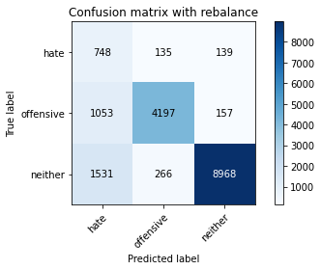

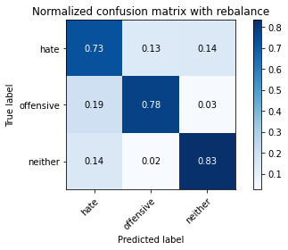

precision recall f1-score support

hate 0.22 0.73 0.34 1022

offensive 0.91 0.78 0.84 5407

neither 0.97 0.83 0.90 10765

accuracy 0.81 17194

macro avg 0.70 0.78 0.69 17194

weighted avg 0.91 0.81 0.84 17194

average eval_loss: 0.5115497426411441, accuracy: 0.8091776201000349

training 2 epoch...

243.8011519908905 seconds used......

2 training finished! average train loss: 0.4290841007542126

total clf loss: 196.478117659688 total adv loss: 127.87720941752195

evaluating...

Confusion matrix, without normalization

[[ 688 156 178]

[ 949 4306 152]

[ 965 306 9494]]

Normalized confusion matrix

[[0.67318982 0.15264188 0.1741683 ]

[0.17551322 0.79637507 0.02811171]

[0.08964236 0.02842545 0.88193219]]

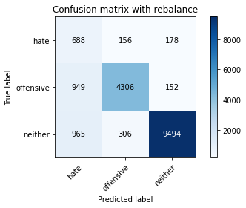

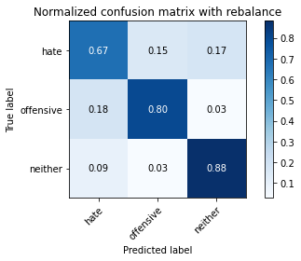

precision recall f1-score support

hate 0.26 0.67 0.38 1022

offensive 0.90 0.80 0.85 5407

neither 0.97 0.88 0.92 10765

accuracy 0.84 17194

macro avg 0.71 0.78 0.72 17194

weighted avg 0.90 0.84 0.87 17194

average eval_loss: 0.4361717913819607, accuracy: 0.8426195184366639

training 3 epoch...

243.83283019065857 seconds used......

3 training finished! average train loss: 0.3103473975531269

total clf loss: 144.07507072761655 total adv loss: 131.82347070798278

evaluating...

Confusion matrix, without normalization

[[ 692 152 178]

[1040 4193 174]

[1139 292 9334]]

Normalized confusion matrix

[[0.67710372 0.14872798 0.1741683 ]

[0.19234326 0.77547623 0.03218051]

[0.10580585 0.02712494 0.86706921]]

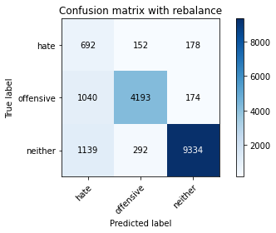

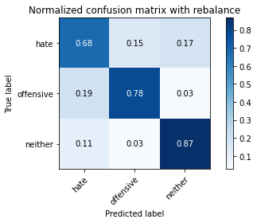

precision recall f1-score support

hate 0.24 0.68 0.36 1022

offensive 0.90 0.78 0.83 5407

neither 0.96 0.87 0.91 10765

accuracy 0.83 17194

macro avg 0.70 0.77 0.70 17194

weighted avg 0.90 0.83 0.86 17194

average eval_loss: 0.5141409904782682, accuracy: 0.8269745259974409

training 4 epoch...

243.78661513328552 seconds used......

4 training finished! average train loss: 0.20097148221229996

total clf loss: 95.7913319580257 total adv loss: 135.21930553764105

evaluating...

Confusion matrix, without normalization

[[ 697 185 140]

[ 929 4362 116]

[1415 453 8897]]

Normalized confusion matrix

[[0.68199609 0.18101761 0.1369863 ]

[0.17181431 0.80673201 0.02145367]

[0.1314445 0.04208082 0.82647469]]

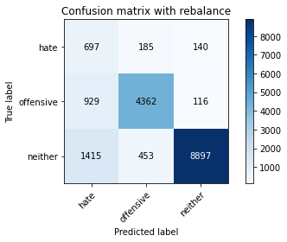

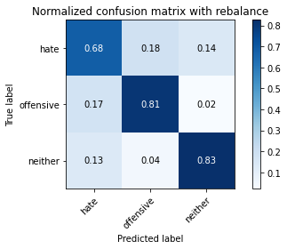

precision recall f1-score support

hate 0.23 0.68 0.34 1022

offensive 0.87 0.81 0.84 5407

neither 0.97 0.83 0.89 10765

accuracy 0.81 17194

macro avg 0.69 0.77 0.69 17194

weighted avg 0.90 0.81 0.84 17194

average eval_loss: 0.6334466300579871, accuracy: 0.8116784924973828

training 5 epoch...

244.03317880630493 seconds used......

5 training finished! average train loss: 0.1212275894085454

total clf loss: 60.666971842292696 total adv loss: 139.26299422234297

evaluating...

Confusion matrix, without normalization

[[ 614 242 166]

[ 727 4527 153]

[1180 446 9139]]

Normalized confusion matrix

[[0.60078278 0.23679061 0.16242661]

[0.13445534 0.83724801 0.02829665]

[0.10961449 0.04143056 0.84895495]]

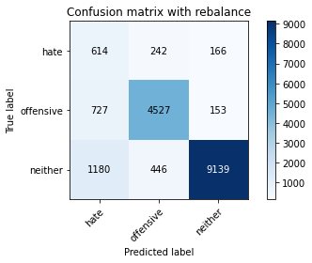

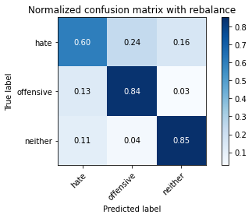

precision recall f1-score support

hate 0.24 0.60 0.35 1022

offensive 0.87 0.84 0.85 5407

neither 0.97 0.85 0.90 10765

accuracy 0.83 17194

macro avg 0.69 0.76 0.70 17194

weighted avg 0.89 0.83 0.85 17194

average eval_loss: 0.6612610438816943, accuracy: 0.8305222752122834

2 run...

training 1 epoch...

244.16713404655457 seconds used......

1 training finished! average train loss: 0.6017538688521891

total clf loss: 273.8915265798569 total adv loss: 146.2912544235587

evaluating...

Confusion matrix, without normalization

[[ 641 265 116]

[ 466 4850 91]

[1395 496 8874]]

Normalized confusion matrix

[[0.62720157 0.2592955 0.11350294]

[0.08618458 0.89698539 0.01683004]

[0.12958662 0.04607524 0.82433813]]

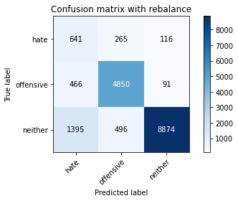

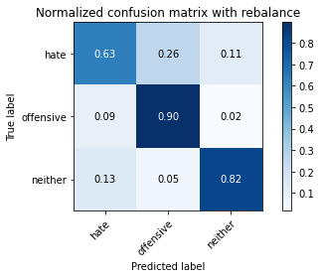

precision recall f1-score support

hate 0.26 0.63 0.36 1022

offensive 0.86 0.90 0.88 5407

neither 0.98 0.82 0.89 10765

accuracy 0.84 17194

macro avg 0.70 0.78 0.71 17194

weighted avg 0.90 0.84 0.86 17194

average eval_loss: 0.49174090894155725, accuracy: 0.835465860183785

training 2 epoch...

244.21497082710266 seconds used......

2 training finished! average train loss: 0.42976620677295174

total clf loss: 196.61874178051949 total adv loss: 124.64624335616827

evaluating...

Confusion matrix, without normalization

[[ 577 188 257]

[ 641 4468 298]

[ 482 250 10033]]

Normalized confusion matrix

[[0.56457926 0.18395303 0.25146771]

[0.11855003 0.82633623 0.05511374]

[0.04477473 0.02322341 0.93200186]]

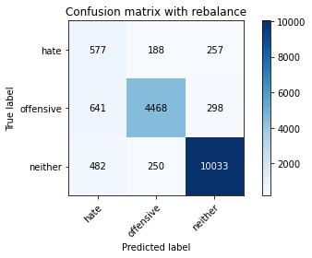

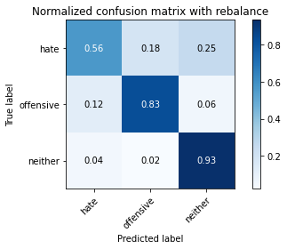

precision recall f1-score support

hate 0.34 0.56 0.42 1022

offensive 0.91 0.83 0.87 5407

neither 0.95 0.93 0.94 10765

accuracy 0.88 17194

macro avg 0.73 0.77 0.74 17194

weighted avg 0.90 0.88 0.89 17194

average eval_loss: 0.35053468575744434, accuracy: 0.8769338141212051

training 3 epoch...

244.5236279964447 seconds used......

3 training finished! average train loss: 0.31032186426205505

total clf loss: 143.9703742340207 total adv loss: 129.9557731896639

evaluating...

Confusion matrix, without normalization

[[ 661 215 146]

[ 690 4498 219]

[1334 319 9112]]

Normalized confusion matrix

[[0.64677104 0.21037182 0.14285714]

[0.12761235 0.83188459 0.04050305]

[0.12392011 0.02963307 0.84644682]]

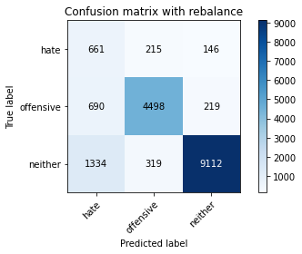

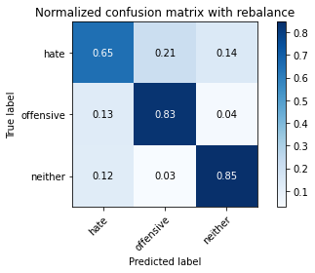

precision recall f1-score support

hate 0.25 0.65 0.36 1022

offensive 0.89 0.83 0.86 5407

neither 0.96 0.85 0.90 10765

accuracy 0.83 17194

macro avg 0.70 0.78 0.71 17194

weighted avg 0.90 0.83 0.86 17194

average eval_loss: 0.515777260675853, accuracy: 0.8299988368035361

training 4 epoch...

244.49006462097168 seconds used......

4 training finished! average train loss: 0.20022970816208802

total clf loss: 95.39158765599132 total adv loss: 133.79653695970774

evaluating...

Confusion matrix, without normalization

[[ 788 134 100]

[1352 3959 96]

[2413 314 8038]]

Normalized confusion matrix

[[0.77103718 0.13111546 0.09784736]

[0.25004624 0.732199 0.01775476]

[0.22415235 0.0291686 0.74667905]]

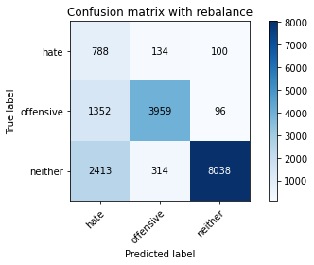

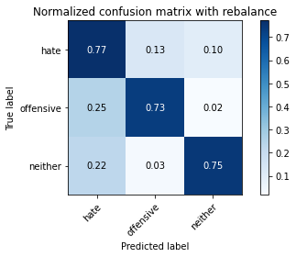

precision recall f1-score support

hate 0.17 0.77 0.28 1022

offensive 0.90 0.73 0.81 5407

neither 0.98 0.75 0.85 10765

accuracy 0.74 17194

macro avg 0.68 0.75 0.65 17194

weighted avg 0.90 0.74 0.80 17194

average eval_loss: 0.8709972114237242, accuracy: 0.7435733395370479

training 5 epoch...

244.2890272140503 seconds used......

5 training finished! average train loss: 0.13062974951875397

total clf loss: 64.54696491826326 total adv loss: 133.55971536785364

evaluating...

Confusion matrix, without normalization

[[ 669 240 113]

[ 669 4628 110]

[1889 500 8376]]

Normalized confusion matrix

[[0.65459883 0.23483366 0.11056751]

[0.1237285 0.8559275 0.020344 ]

[0.17547608 0.04644682 0.7780771 ]]

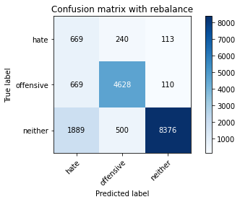

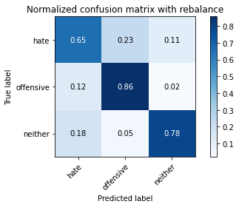

precision recall f1-score support

hate 0.21 0.65 0.31 1022

offensive 0.86 0.86 0.86 5407

neither 0.97 0.78 0.87 10765

accuracy 0.80 17194

macro avg 0.68 0.76 0.68 17194

weighted avg 0.89 0.80 0.83 17194

average eval_loss: 0.7543387242051405, accuracy: 0.7952192625334419

3 run...

training 1 epoch...

244.47114968299866 seconds used......

1 training finished! average train loss: 0.6018852143134275

total clf loss: 273.9555525928736 total adv loss: 146.40805374085903

evaluating...

Confusion matrix, without normalization

[[ 516 299 207]

[ 362 4881 164]

[ 648 383 9734]]

Normalized confusion matrix

[[0.50489237 0.2925636 0.20254403]

[0.06695025 0.9027187 0.03033105]

[0.06019508 0.03557826 0.90422666]]

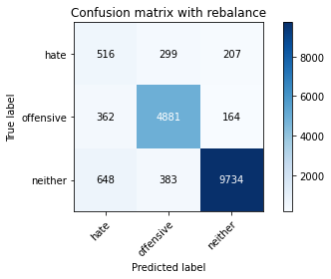

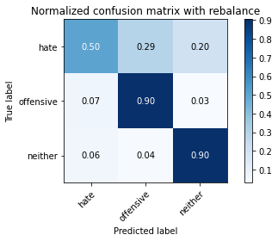

precision recall f1-score support

hate 0.34 0.50 0.41 1022

offensive 0.88 0.90 0.89 5407

neither 0.96 0.90 0.93 10765

accuracy 0.88 17194

macro avg 0.73 0.77 0.74 17194

weighted avg 0.90 0.88 0.89 17194

average eval_loss: 0.37324307883201646, accuracy: 0.8800162847504943

training 2 epoch...

244.58906722068787 seconds used......

2 training finished! average train loss: 0.4306434349369249

total clf loss: 197.0391035452485 total adv loss: 125.28124310076237

evaluating...

Confusion matrix, without normalization

[[ 695 174 153]

[ 826 4395 186]

[1194 288 9283]]

Normalized confusion matrix

[[0.68003914 0.1702544 0.14970646]

[0.15276493 0.81283521 0.03439985]

[0.110915 0.02675337 0.86233163]]

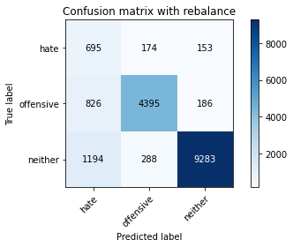

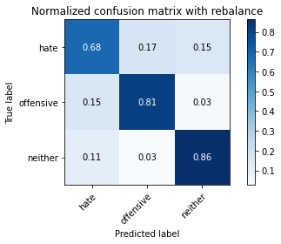

precision recall f1-score support

hate 0.26 0.68 0.37 1022

offensive 0.90 0.81 0.86 5407

neither 0.96 0.86 0.91 10765

accuracy 0.84 17194

macro avg 0.71 0.79 0.71 17194

weighted avg 0.90 0.84 0.86 17194

average eval_loss: 0.4533262151098529, accuracy: 0.8359311387693381

training 3 epoch...

244.58689069747925 seconds used......

3 training finished! average train loss: 0.3106794938882371

total clf loss: 143.98551962524652 total adv loss: 127.09007412940264

evaluating...

Confusion matrix, without normalization

[[ 757 156 109]

[1150 4131 126]

[1844 285 8636]]

Normalized confusion matrix

[[0.7407045 0.15264188 0.10665362]

[0.21268726 0.76400962 0.02330313]

[0.17129587 0.02647469 0.80222945]]

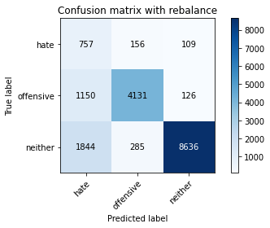

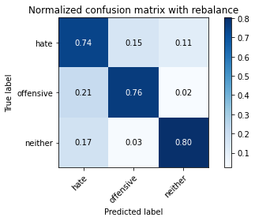

precision recall f1-score support

hate 0.20 0.74 0.32 1022

offensive 0.90 0.76 0.83 5407

neither 0.97 0.80 0.88 10765

accuracy 0.79 17194

macro avg 0.69 0.77 0.67 17194

weighted avg 0.91 0.79 0.83 17194

average eval_loss: 0.6202547310050144, accuracy: 0.7865534488775154

training 4 epoch...

244.2451412677765 seconds used......

4 training finished! average train loss: 0.1906245232330589

total clf loss: 90.98365367390215 total adv loss: 130.7397959306836

evaluating...

Confusion matrix, without normalization

[[ 736 176 110]

[ 954 4341 112]

[1951 388 8426]]

Normalized confusion matrix

[[0.72015656 0.17221135 0.10763209]

[0.17643795 0.80284816 0.02071389]

[0.18123549 0.03604273 0.78272178]]

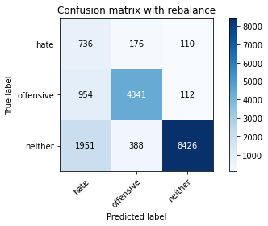

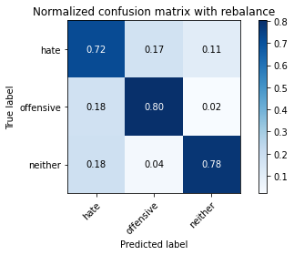

precision recall f1-score support

hate 0.20 0.72 0.32 1022

offensive 0.89 0.80 0.84 5407

neither 0.97 0.78 0.87 10765

accuracy 0.79 17194

macro avg 0.69 0.77 0.68 17194

weighted avg 0.90 0.79 0.83 17194

average eval_loss: 0.8217086021983346, accuracy: 0.7853320925904386

training 5 epoch...

244.07141971588135 seconds used......

5 training finished! average train loss: 0.12499181810833733

total clf loss: 62.00383395329118 total adv loss: 132.64916667342186

evaluating...

Confusion matrix, without normalization

[[ 718 171 133]

[1045 4202 160]

[1664 314 8787]]

Normalized confusion matrix

[[0.70254403 0.16731898 0.13013699]

[0.19326799 0.77714074 0.02959127]

[0.15457501 0.0291686 0.81625639]]

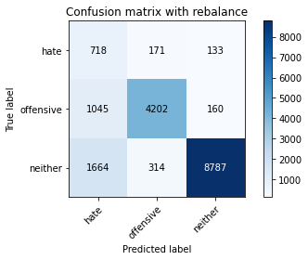

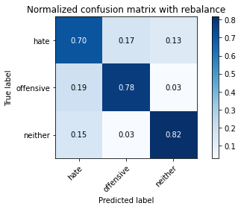

precision recall f1-score support

hate 0.21 0.70 0.32 1022

offensive 0.90 0.78 0.83 5407

neither 0.97 0.82 0.89 10765

accuracy 0.80 17194

macro avg 0.69 0.77 0.68 17194

weighted avg 0.90 0.80 0.84 17194

average eval_loss: 0.7883952552658441, accuracy: 0.7971966965220426

4 run...

training 1 epoch...

244.0862808227539 seconds used......

1 training finished! average train loss: 0.6017393391436433

total clf loss: 273.725780159235 total adv loss: 143.1050501652062

evaluating...

Confusion matrix, without normalization

[[ 677 198 147]

[ 697 4581 129]

[1077 370 9318]]

Normalized confusion matrix

[[0.66242661 0.19373777 0.14383562]

[0.12890697 0.84723507 0.02385796]

[0.10004645 0.03437065 0.86558291]]

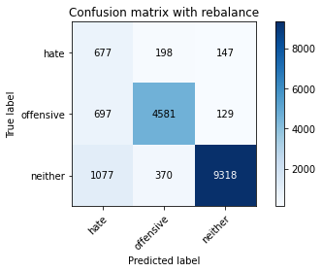

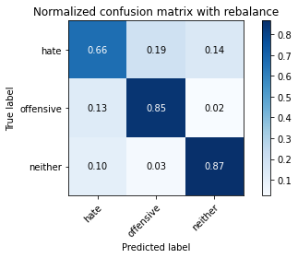

precision recall f1-score support

hate 0.28 0.66 0.39 1022

offensive 0.89 0.85 0.87 5407

neither 0.97 0.87 0.92 10765

accuracy 0.85 17194

macro avg 0.71 0.79 0.72 17194

weighted avg 0.90 0.85 0.87 17194

average eval_loss: 0.4394754907852689, accuracy: 0.847737582877748

training 2 epoch...

244.07571482658386 seconds used......

2 training finished! average train loss: 0.4323867086665894

total clf loss: 197.83215114474297 total adv loss: 125.69678108021617

evaluating...

Confusion matrix, without normalization

[[ 655 184 183]

[ 740 4490 177]

[ 937 297 9531]]

Normalized confusion matrix

[[0.6409002 0.18003914 0.17906067]

[0.13685963 0.83040503 0.03273534]

[0.08704134 0.02758941 0.88536925]]

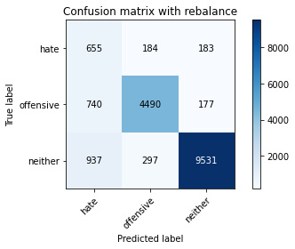

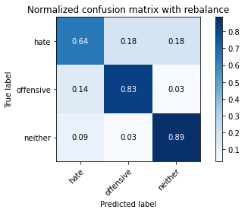

precision recall f1-score support

hate 0.28 0.64 0.39 1022

offensive 0.90 0.83 0.87 5407

neither 0.96 0.89 0.92 10765

accuracy 0.85 17194

macro avg 0.72 0.79 0.73 17194

weighted avg 0.90 0.85 0.87 17194

average eval_loss: 0.4156471943699343, accuracy: 0.8535535651971617

training 3 epoch...

244.22041034698486 seconds used......

3 training finished! average train loss: 0.32556064722903966

total clf loss: 150.6108453348279 total adv loss: 127.7495682016015

evaluating...

Confusion matrix, without normalization

[[ 670 195 157]

[ 797 4454 156]

[1322 293 9150]]

Normalized confusion matrix

[[0.6555773 0.19080235 0.15362035]

[0.14740152 0.82374699 0.02885149]

[0.12280539 0.02721784 0.84997678]]

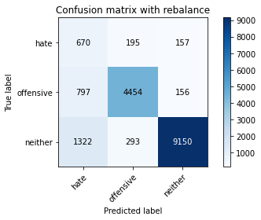

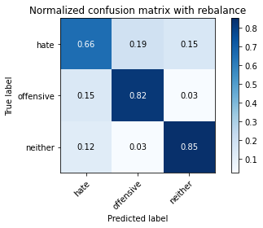

precision recall f1-score support

hate 0.24 0.66 0.35 1022

offensive 0.90 0.82 0.86 5407

neither 0.97 0.85 0.90 10765

accuracy 0.83 17194

macro avg 0.70 0.78 0.71 17194

weighted avg 0.90 0.83 0.86 17194

average eval_loss: 0.5100500290087142, accuracy: 0.8301733162731185

training 4 epoch...

244.04163026809692 seconds used......

4 training finished! average train loss: 0.2122580711403967

total clf loss: 100.74509613029659 total adv loss: 134.29540653154254

evaluating...

Confusion matrix, without normalization

[[ 710 182 130]

[ 969 4317 121]

[1676 353 8736]]

Normalized confusion matrix

[[0.69471624 0.17808219 0.12720157]

[0.17921213 0.79840947 0.0223784 ]

[0.15568974 0.03279145 0.81151881]]

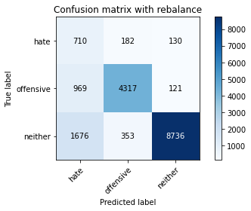

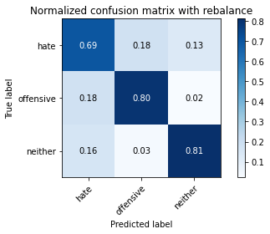

precision recall f1-score support

hate 0.21 0.69 0.32 1022

offensive 0.89 0.80 0.84 5407

neither 0.97 0.81 0.88 10765

accuracy 0.80 17194

macro avg 0.69 0.77 0.68 17194

weighted avg 0.90 0.80 0.84 17194

average eval_loss: 0.6733788527634947, accuracy: 0.8004536466209142

training 5 epoch...

244.69290280342102 seconds used......

5 training finished! average train loss: 0.13723004759451202

total clf loss: 67.81667920388281 total adv loss: 140.47536094114184

evaluating...

Confusion matrix, without normalization

[[ 645 205 172]

[ 793 4405 209]

[1204 352 9209]]

Normalized confusion matrix

[[0.63111546 0.20058708 0.16829746]

[0.14666173 0.81468467 0.0386536 ]

[0.11184394 0.03269856 0.8554575 ]]

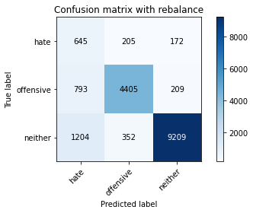

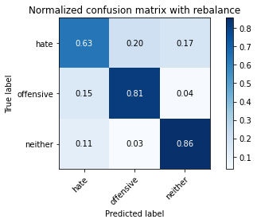

precision recall f1-score support

hate 0.24 0.63 0.35 1022

offensive 0.89 0.81 0.85 5407

neither 0.96 0.86 0.90 10765

accuracy 0.83 17194

macro avg 0.70 0.77 0.70 17194

weighted avg 0.89 0.83 0.85 17194

average eval_loss: 0.6453688557757887, accuracy: 0.8293009189252065

5 run...

training 1 epoch...

244.5977747440338 seconds used......

1 training finished! average train loss: 0.5977169721645911

total clf loss: 272.2098317593336 total adv loss: 148.4242515936494

evaluating...

Confusion matrix, without normalization

[[ 612 239 171]

[ 510 4723 174]

[1032 355 9378]]

Normalized confusion matrix

[[0.59882583 0.23385519 0.16731898]

[0.09432217 0.87349732 0.03218051]

[0.09586623 0.03297724 0.87115653]]

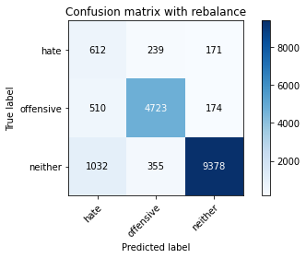

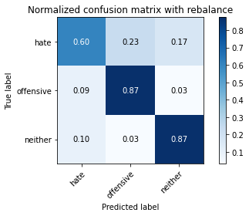

precision recall f1-score support

hate 0.28 0.60 0.39 1022

offensive 0.89 0.87 0.88 5407

neither 0.96 0.87 0.92 10765

accuracy 0.86 17194

macro avg 0.71 0.78 0.73 17194

weighted avg 0.90 0.86 0.87 17194

average eval_loss: 0.4171623512929262, accuracy: 0.8557054786553449

training 2 epoch...

244.74766039848328 seconds used......

2 training finished! average train loss: 0.43209402049569995

total clf loss: 197.73295015096664 total adv loss: 126.3059855028987

evaluating...

Confusion matrix, without normalization

[[ 745 137 140]

[1197 4067 143]

[1451 234 9080]]

Normalized confusion matrix

[[0.72896282 0.13405088 0.1369863 ]

[0.22137969 0.75217311 0.0264472 ]

[0.13478867 0.02173711 0.84347422]]

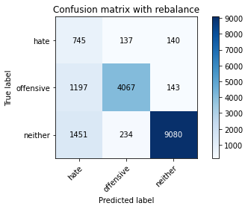

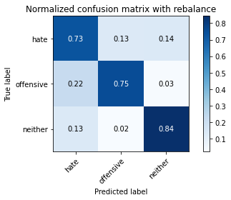

precision recall f1-score support

hate 0.22 0.73 0.34 1022

offensive 0.92 0.75 0.83 5407

neither 0.97 0.84 0.90 10765

accuracy 0.81 17194

macro avg 0.70 0.77 0.69 17194

weighted avg 0.91 0.81 0.84 17194

average eval_loss: 0.5057409808819378, accuracy: 0.807956263812958

training 3 epoch...

244.61049103736877 seconds used......

3 training finished! average train loss: 0.3114092944286612

total clf loss: 144.4968178346753 total adv loss: 130.8500070720911

evaluating...

Confusion matrix, without normalization

[[ 706 189 127]

[ 879 4349 179]

[1752 334 8679]]

Normalized confusion matrix

[[0.69080235 0.18493151 0.12426614]

[0.16256704 0.80432772 0.03310523]

[0.16274965 0.03102647 0.80622387]]

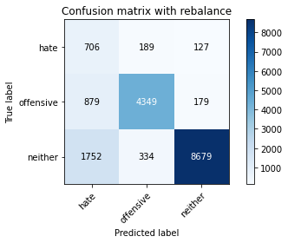

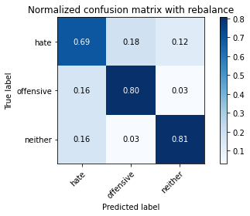

precision recall f1-score support

hate 0.21 0.69 0.32 1022

offensive 0.89 0.80 0.85 5407

neither 0.97 0.81 0.88 10765

accuracy 0.80 17194

macro avg 0.69 0.77 0.68 17194

weighted avg 0.90 0.80 0.84 17194

average eval_loss: 0.6275541031559886, accuracy: 0.7987670117482842

training 4 epoch...

244.66363835334778 seconds used......

4 training finished! average train loss: 0.20426220286208674

total clf loss: 97.24777188804 total adv loss: 135.19231917709112

evaluating...

Confusion matrix, without normalization

[[ 678 188 156]

[ 972 4258 177]

[1391 299 9075]]

Normalized confusion matrix

[[0.66340509 0.18395303 0.15264188]

[0.17976697 0.78749769 0.03273534]

[0.12921505 0.0277752 0.84300975]]

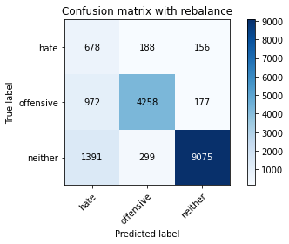

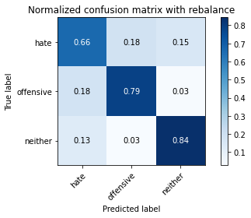

precision recall f1-score support

hate 0.22 0.66 0.33 1022

offensive 0.90 0.79 0.84 5407

neither 0.96 0.84 0.90 10765

accuracy 0.81 17194

macro avg 0.69 0.76 0.69 17194

weighted avg 0.90 0.81 0.85 17194

average eval_loss: 0.622687004426451, accuracy: 0.8148772827730604

training 5 epoch...

244.7551782131195 seconds used......

5 training finished! average train loss: 0.13187396572797683

total clf loss: 65.34592270478606 total adv loss: 138.51511645317078

evaluating...

Confusion matrix, without normalization

[[ 668 231 123]

[ 785 4498 124]

[1786 505 8474]]

Normalized confusion matrix

[[0.65362035 0.2260274 0.12035225]

[0.14518217 0.83188459 0.02293323]

[0.16590804 0.04691129 0.78718068]]

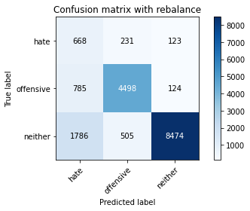

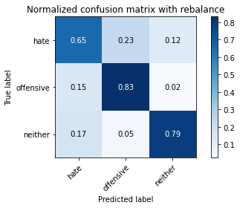

precision recall f1-score support

hate 0.21 0.65 0.31 1022

offensive 0.86 0.83 0.85 5407

neither 0.97 0.79 0.87 10765

accuracy 0.79 17194

macro avg 0.68 0.76 0.68 17194

weighted avg 0.89 0.79 0.83 17194

average eval_loss: 0.767147969064671, accuracy: 0.7932999883680354

add Codeadd Markdown